CALAMACIL:
I am Calamacil, The Sword of Light, Darkness Fear my bite.
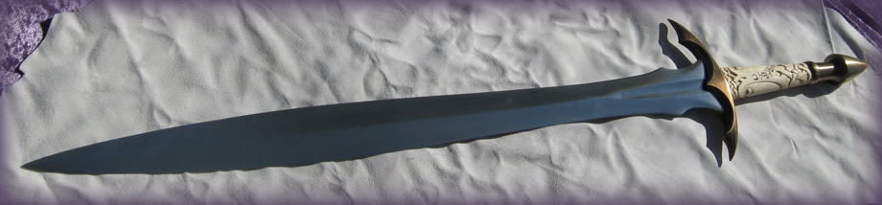
Well Iv got some time off after my Shoulder Operation, so Iv decided its time to catch up on some reviews Iv been meaning to do for a while now . This will be No. 1 of 14 reviews to follow over the next month or so.
Introduction:
This was a lovely gift from my wife ,in fact my last 2 Fable Blades have been gifts from my lovely wife
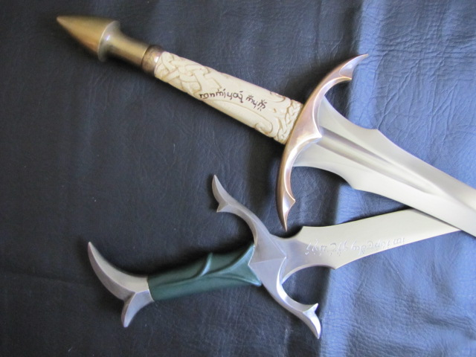
They were pretty much a surprise until they arrived and she handled everything with Brendan ,luckily Brendan knows exactly what I like in my swords and what he and my wife came up with is my dream Leaf Blade . I own 5 Fable Blades now and my Calamacil is my favorite piece ,Brendan really did a great job on this one ,in fact so good that the sword itself would have been right at home in Middle Earth .
The idea (which was my wife’s idea) was to have these two swords Calamacil and Estelhang as “sister” swords with Calamacil being the Sword of Light and Estelhang the Sword of Hope , Protector of Light . There is a third sword to still be added to this set apparently that my wife has discussed with Brendan already ,but im not sure when it is to be made as it is to be a surprise ,all iv been told is that it will be an evil sword and be called the sword of darkness . So in essence this will become a set of 3 swords , 2 being Good and 1 evil counter part .
Now for the review and pics
Historical overview:
This is a functional fantasy sword and as such has no historical background
Specs:
Blade: 9260 high carbon spring steel. Oil Quenched and Tempered twice for hardness ~ 52Rc
Grip: Holly (Ilex Opaca)
Hilt Furniture: Brass
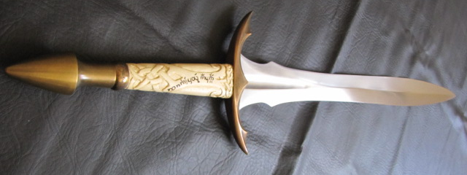
Initial Impressions:
To sum this up in a single word – WOW !
I was blown away when handed the package ,well that’s a bit of a lie actually , I got to see it earlier than I was supposed to as I was home when the courier arrived and the wife was not . I knew when I saw the packaging (sword in a tube) that it was a Fable Blade ,so I just could not resist opening it and taking a peek . Before this sword I had received many a sword ,but this sword was literally a dream come true in many ways . I had been chatting to Brendan for a while about my perfect leaf blade and what I received was that and then some .
From the blade shape to the hilt design and carvings it is just a stunning piece made with the typical care and expertise that one associates with Brendan’s work .
This is a sword that had been floating in my want list for a very long time ,but before this I had never really seen anything that had caught my attention so fully . Iv seen and handled a lot of leaf blades and while some of them have been pretty good there was always just something missing ,that is until I received Calamacil .
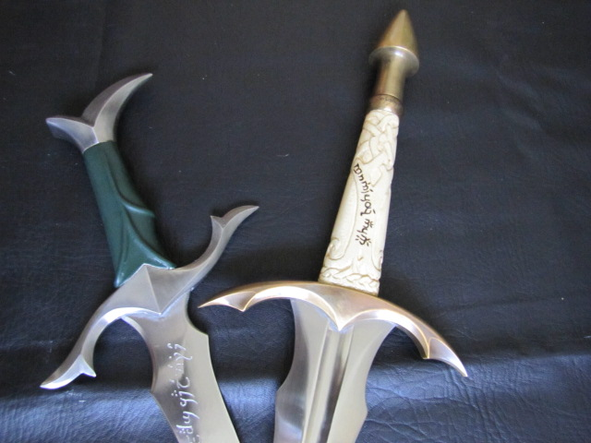
A big thank you must go out to Brendan , to be honest my wife knows very little about swords other than what looks nice to her and because of this in the past when she has ordered me a sword some makers have taken advantage of this and tried to cut corners so to speak ,but Brendan was great a true professional and it was because of this that my wife went back and had Estelhang made and has said that any future purchases will be done through Fable Blades . So im smiling all around , means more Fable Blades to add to my collection in the years to come
Here are some quick pics courtesy of Brendan of my Sword in progress :
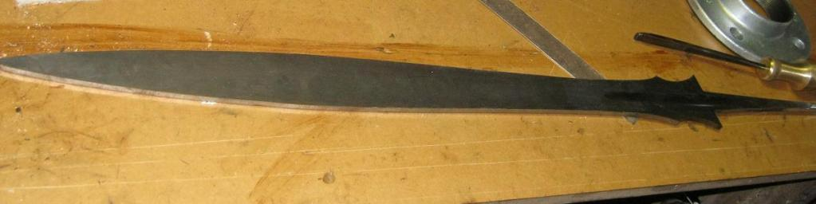
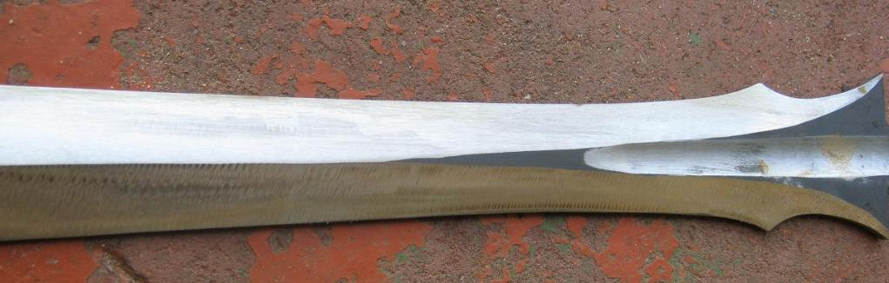
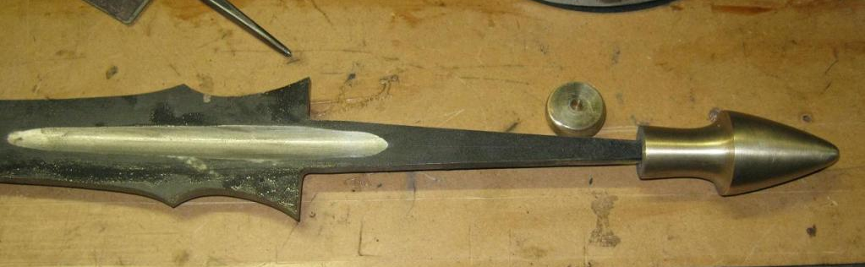
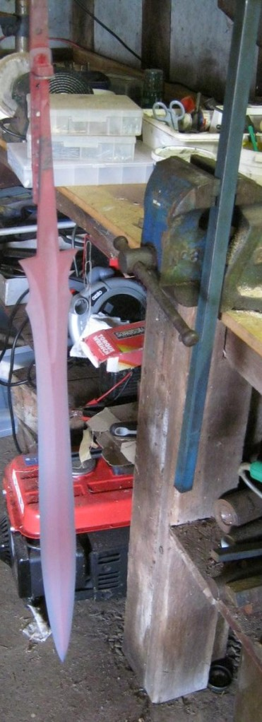
Statistics:
Weight: 1488g (3.25lb)
Length O/all: 927mm (36.5”)
Blade Length: 686cm (27”)
Grip Length: 126mm (5”)
Guard Length: 171mm (6.7")
Blade Thickness: 6mm (0.236”) at base > 4.6mm at belly (0.181”) > 3.6mm (0.141”) at 2” from tip.
Blade Breadth: 69mm (2.75”) @ base > 38mm (1.5”) @ waist > 53mm (2.1”) at belly
Point of Balance: ~75mm (3”) from base of blade
Centre Of Percussion: ~40cm (16")
Hilt Node of Percussion: ~6cm (2.4") behind guard - centre of grip
Blade: 9260 high carbon spring steel. Oil Quenched and Tempered twice for hardness ~ 52Rc
Grip: Holly (Ilex Opaca)
Hilt Furniture: Brass
Components:
The Blade:
This is one of the first things that caught my attention when I handled her for the first time , the blade is a lot more substantial than my other leafies I own which to be honest is great as I always found that my other leafies tended to be a little thin both in thickness and width ,while they are all functional I always wondered just how much they could handle cutting wise . Calamacil is in a whole new league ,this sword and blade just feels so solid in true Fable Blade style .With this blade I have no doubts at all in its cutting ability and durability .
Blade Thickness: 6mm (0.236”) at base > 4.6mm at belly (0.181”) > 3.6mm (0.141”) at 2” from tip.
Blade Breadth: 69mm (2.75”) @ base > 38mm (1.5”) @ waist > 53mm (2.1”) at belly
Blade Length: 686cm (27”)
Blade: 9260 high carbon spring steel. Oil Quenched and Tempered twice for hardness ~ 52Rc
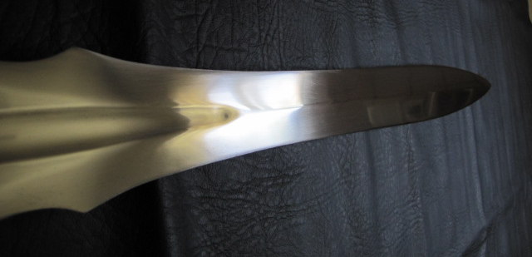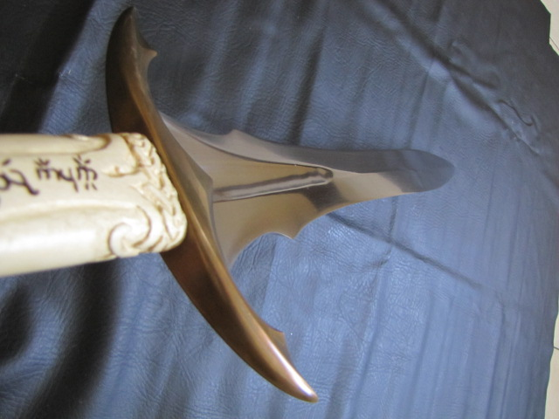
The Handle:
This is a work of art in its own right with the color of the wood and the carvings just adding a whole elvish feel to the piece
Grip: Holly (Ilex Opaca)
Grip Length: 126mm (5”)
Inscriptions:
These are carved onto the grip and look really good in person . It gives the whole sword a very earthy natural look and also provides a good grip to the sword
Grip - Tengwar: Im i Calamacil mornië caurë nacnya
( I am the sword of Light, Darkness fear my Bite)
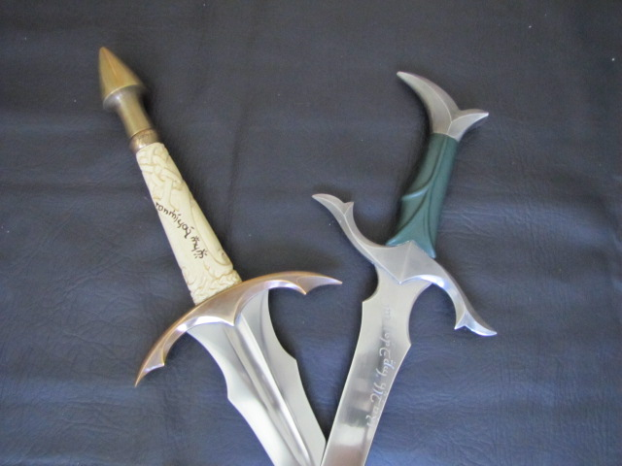
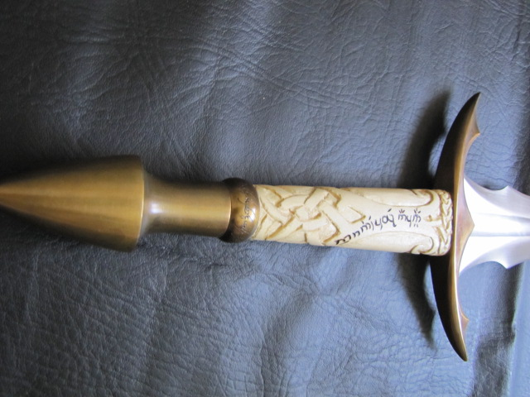
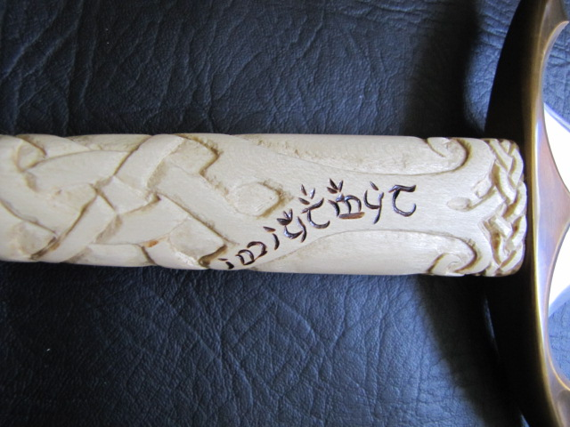
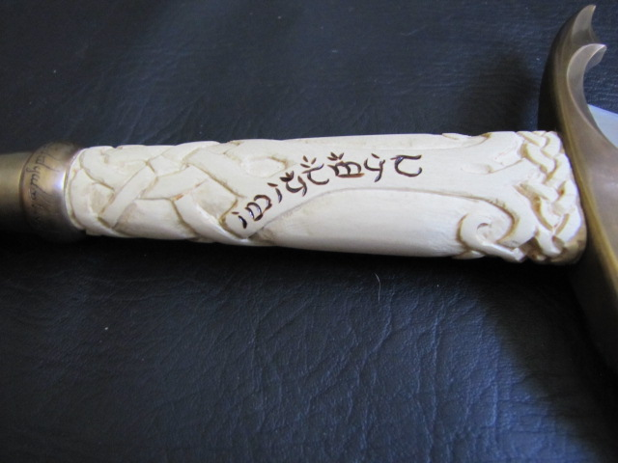
The Guard:
This has been done perfectly and I just love the curves of the guard . The brass is great because over time it has darkened and given the whole sword more of an old world feel to it .
Hilt Furniture: Brass
Guard Length: 171mm (6.7")
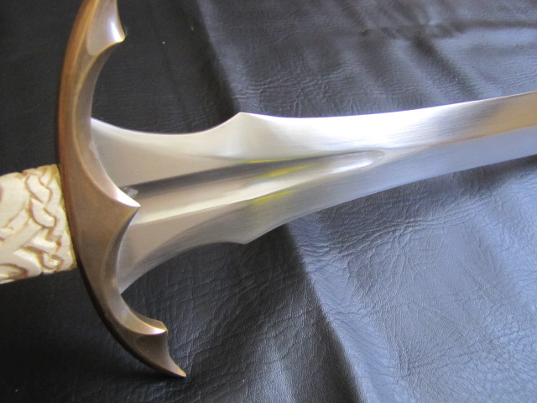
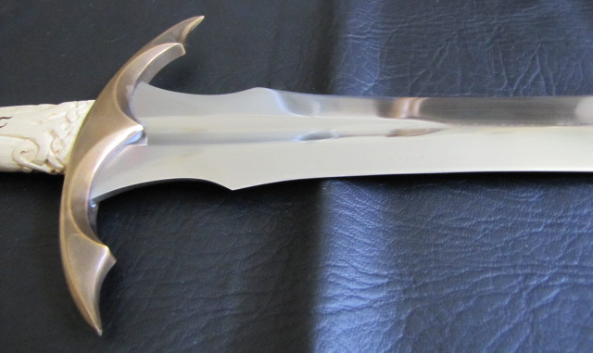
The Pommel:
The shape of the pommel is something that I like because it allows one to almost use 2 hands on the grip for a really ferocious Orc Strike .
It has an added little feature in that it has a “One Ring” Ferrule which I think was a very nice touch added by both my wife and Brendan as I am a Lord Of The Rings fan .
Hilt Furniture: Brass
One Ring Ferrule: In Tengwar lettering of the Black Speech...
"Ash nazg durbatulûk, ash nazg gimbatul,
Ash nazg thrakatulûk agh burzum-ishi krimpatul. "
"One ring to rule them all, one ring to find them,
One ring to bring them all and in the darkness bind them."
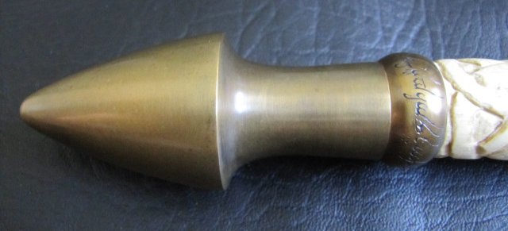
Handling Characteristics:
This sword just begs to be cut with . The sword is really well balanced allowing for some powerful cutting ,but at the same time allows for a quick recovery .
It is definitely one of my more enjoyable pieces to cut with and handle . The slightly longer handle which was requested by my wife actually really worked out very well as there is plenty of grip room for your hands making it comfortable to handle for a prolonged period of time . I did however start using gloves with her ,not out of discomfort ,but purely because I did not want to ruin the “white” grip by making it dirty .
Point of Balance: ~75mm (3”) from base of blade
Centre Of Percussion: ~40cm (16")
Hilt Node of Percussion: ~6cm (2.4") behind guard - centre of grip
Weight: 1488g (3.25lb)
Cutting:
Iv honestly not done a huge amount of cutting with her , a young family and my recent operation has not allowed me too much time for cutting . I did do some when I first received her though and in short she is a monster when cutting sailing through Mats with ease . In fact I managed to clip the cutting stand on my one pass and did some mortal damage to the stand whilst Calamacil came away unscathed and unscratched , Orcs beware
It’s a very fun sword to cut with and I really need to take her out again once iv recovered and put her through her paces . I was a little weary at first as I was worried that the grip might turn out to be a little slippery after a bit of cutting ,but the carvings do a wonderful job of providing ample grip whilst cutting . I did start using gloves after a while though ,purely as I did not want to discolor the beautiful white grip .
Conclusions:
This is one of my my prized possessions , my perfect leaf bladed sword . Brendan has out done himself with this sword . A truly functional and beautiful sword all in one , fit for middle earth . My go to sword for Orc Slaying together with my Borderwatch .
Pros:
There are so many ,here are but a few :
Beautiful sword
Functional power hungry blade with awesome cutting power
Great handling
My dream leaf blade realized
Great attention to detail
Cons:
Honestly I am really battling to find any and if I really have to find something it would be that the white wood lends itself to becoming dirty under prolonged use ,but this being said I cannot imagine this sword any differently as the white wood just compliments the brass so well and rounds the sword off perfectly . Yes leather might have been an option ,but honestly it would not have looked as good and I am very glad that Brendan and my wife went for the white Holly .
The Bottom Line:
For anyone ever considering a Fable Blade Commission , do not hesitate . Brendan is a true professional and a true artist , he is one of my favorite sword smiths and I hope to get many a Fable Blade piece in the future from him . His work is really top class with attention paid to all the small details one often over looks . He, in my opinion , also makes one of the best Leaf Blades out there ,now all I need to get from him is a nice two handed leaf blade to go with my Calamacil . My only regret is that I wish I could have gotten a scabbard made for the Calamacil at the same time as Brendan's Scabbard work is really looking very good and I can only imagine how good a nice scabbard with the inscriptions and a fancy chape would have looked to go with the sword.

